IBM IDG, APIM & ADP Version Upgradation

Table of Contents

Introduction 3
DataPower 3
API Management 5
Advanced Developer Portal 6

Introduction
This document provides the information/instructions for upgrading the version of DataPower, API Managemet & Advanced Developer Portal.

DataPower
- Login to DataPower
- In the Main Menu under “Files and administration” click System control
- In the Boot image section
- Tick the license agreement check box
- Click upload & browse for the idg7202.scrypt4 file
- Click boot image

STEP1
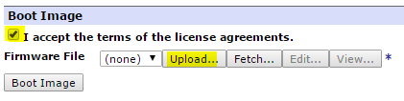

STEP2
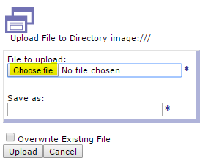

STEP3

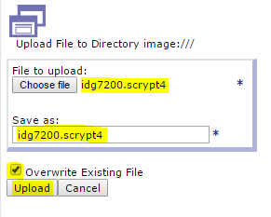
STEP4

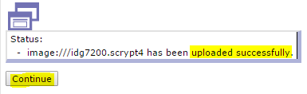

STEP5
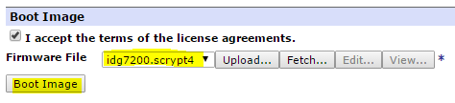

STEP6
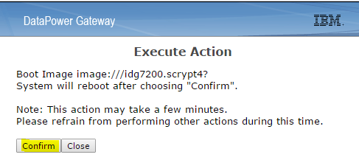

STEP7

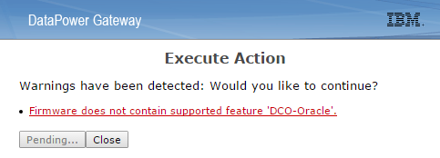

STEP8
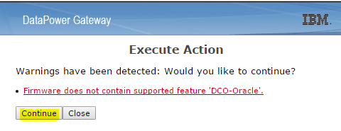

STEP9

Wait for mininum 30 mins and check the version of DataPower, it should display new version.

API Management
For upgrading APIM version an FTP server is required from where the APIM management appliance will pull the file (*.vcrypt2) and start upgradation using below command.

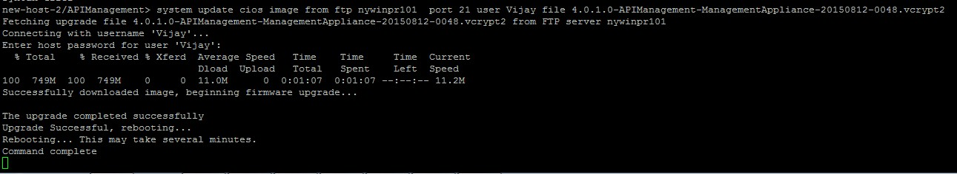

Command:
system update cios image from ftp <ftp server IP> port <port number> user <username> file <4.0.4.0****.vcrypt2>

- As per the sample screenshot file will get downloaded APIM
- Once the file downloaded from ftp server firmware upgradation starts
- Wait for the successful upgradation notification/message
- Once the automatic reboot was done login again from VMWare workstation to APIM VM
- After re-login issue the command system show version to verify the new version.
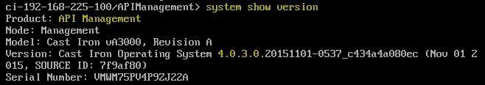

Advanced Developer Portal
- Copy the .sh file from the local drive to advanced developer portal to /home/admin directory using winscp.
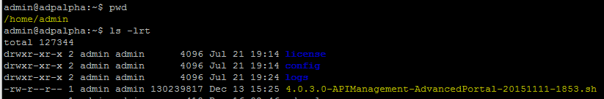
- Open WINSCP and enter the ADP details

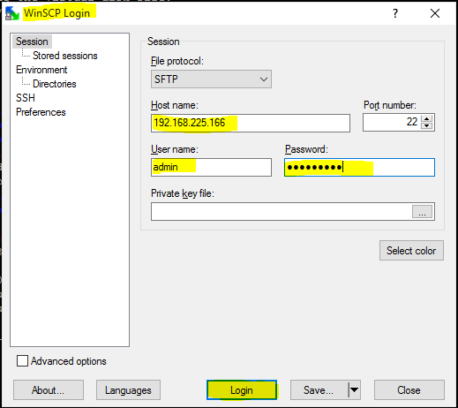

- Drag and drop the require .sh file on to ADP at /home/admin 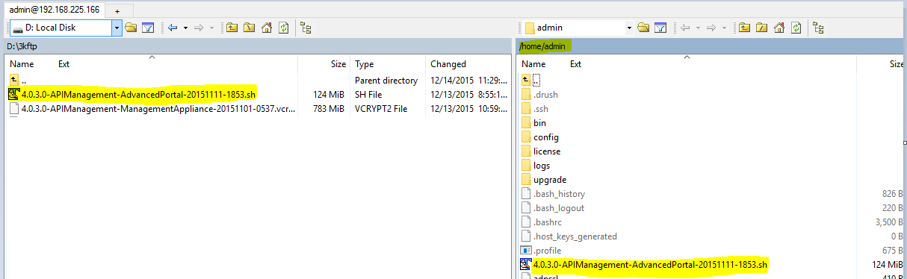
Once the file was available at the location try running the below command
bash 4.0.3.0-APIManagement-AdvancedPortal-20151111-1853.sh -a –i

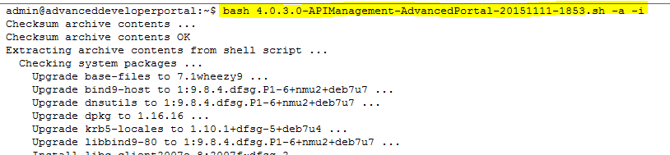

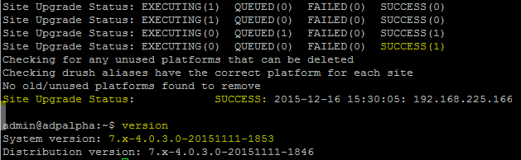
It takes more than 30 mins to complete upgradation .

NOTE: Upgrade APIM first before upgrading ADP (Mandatory)

